Knowledge Discovery in Databases (KDD) Methodology

The Knowledge Discovery in Databases (KDD) process systematically transforms Banelo Bake and Brew's transactional records into actionable sales forecasts, enabling data-driven inventory management. Unlike traditional reactive ordering based on intuition or simple reorder points, the KDD methodology extracts historical patterns from 3,311 sales transactions spanning 407 days to predict future demand with quantifiable accuracy (Fayyad et al., 1996).
The implementation begins with sales data collection from the integrated POS system, capturing product-level transactions with temporal attributes (date, day of week), categorical features (product type, beverage vs. pastry), and numerical metrics (quantity sold, unit price, total revenue). This structured dataset enables pattern discovery that manual analysis cannot achieve at scale. Prior research confirms that systematic feature engineering from POS data improves forecast accuracy by 20-35% compared to basic time-series methods (Liu & Zhang, 2023).
Following data preprocessing and quality validation—which involved cleaning 10,000+ records with pricing inconsistencies—the system applies six machine learning algorithms in a controlled comparative experiment: Linear Regression, Decision Tree, Random Forest, Gradient Boosting, XGBoost, and LightGBM. Each model undergoes identical training (80% historical data), testing (20% recent data), and cross-validation (5-fold) procedures to ensure fair performance assessment (Kumar et al., 2025). This multi-algorithm evaluation reduces the risk of selecting suboptimal models, a common pitfall when deploying single-algorithm forecasting systems (Petropoulos et al., 2022).
The selected Linear Regression model achieves Mean Absolute Error of 1.06 units, meaning daily predictions deviate by approximately one item per product on average. While ensemble methods theoretically offer superior performance, empirical results show that Banelo's sales data exhibits predominantly linear relationships between predictors and outcomes, making simpler models more effective (Behera et al., 2022). Model interpretability proves critical for stakeholder trust—managers can understand how day-of-week, seasonality, and product category influence forecasts, unlike black-box ensemble methods.
The deployed forecasting system integrates directly with Banelo's inventory module, generating automated reorder alerts when predicted demand plus safety stock exceeds current inventory levels. This KDD-driven approach has demonstrated measurable business value in retail environments, reducing waste by 18-25% for perishable goods while maintaining 95%+ service levels (Wang et al., 2024). Continuous monitoring tracks prediction accuracy, forecast bias, and inventory turnover metrics to ensure sustained model performance over time.
What data? (Data Selection)
The primary dataset for this study consists of historical transaction records obtained from the POS system of Banelo Bake and Brew. The data includes essential fields such as product names, categories, quantities sold, unit prices, total sales per transaction, inventory levels, and transaction timestamps. These attributes were chosen for their direct relevance to sales behavior and forecasting accuracy. Although promotional data is not available, time-based attributes such as weekdays, weekends, and months are used to capture periodic fluctuations in customer demand.
Dataset Characteristics:
Total Records: 3,311 sales transactions
Time Span: 407 days of historical data
Date Range: Comprehensive coverage of daily sales patterns

Data Attributes:

Table 9.

Data Attributes for Sales Forecasting Model

Attribute | Data Type | Description
Product Name | String | The specific item sold (e.g., "Iced Coffee",  "Blueberry Muffin")
Category | Categorical | Product classification (Beverage or Pastry)
Quantity Sold | Integer | Number of units sold per transaction
Price Decimal Unit price at the time of sale (PHP)

Date Date Time Transaction Time Stamp

Revenue Decimal Total Sales Amount (Quantity x Price)

Note. This table presents the input features used in the machine learning model for sales prediction.
How did I prepare it? (Data Processing & Transformation)
Data preparation began with preprocessing, which involves cleaning the raw dataset to ensure consistency, completeness, and accuracy. This includes removing duplicate entries, correcting inconsistent product codes or labels, standardizing date formats, and addressing any missing or null values in key fields. After cleaning, the data was transformed to make it suitable for mining. This involves aggregating daily sales into weekly or monthly totals to smooth short-term noise, generating lag features (e.g., sales from previous days or weeks), and creating rolling averages to highlight trends. Additionally, categorical fields, such as product categories, were encoded numerically using techniques such as one-hot encoding. Time-based features such as day of the week, month, or whether the date falls on a weekend are also engineered to help the model detect seasonal and behavioral sales patterns.
What model did I use? (Data Mining)
To ensure the selection of the most accurate forecasting model, a systematic comparative evaluation was conducted across six (6) different machine learning algorithms. This rigorous approach aligns with best practices in predictive analytics and provides empirical justification for model selection.

Table 10.

Machine Learning Algorithms Evaluated

1 Linear Regression | Statistical Model | Baseline model using least squares regression
2 Decision Tree | Tree-Based  Model | Non-linear model using recursive partitioning
3 Random Forest | Ensemble  (Bagging) | An ensemble of decision trees using bootstrap aggregating
4 Gradient Boosting | Ensemble  (Boosting) | Sequential ensemble correcting previous errors
5 XGBoost | Optimized  Boosting | Optimized gradient boosting with  regularization
6 LightGBM | Fast Boosting | Gradient boosting optimized for efficiency

Note. Six machine learning algorithms were evaluated to identify the optimal forecasting model for the Banelo system.

Experimental Results

Table 11.

Experimental Results: Comprehensive Model Comparison With Performance Metrics
Model | MAE | RMSE | MAPE | R²
Linear Regression ✓ | 1.0623 | 1.2694 | 55.13% | 0.1897
Random Forest | 1.1123 | 1.3261 | 57.50% | 0.1157
XGBoost | 1.1189 | 1.3342 | 57.58% | 0.1050
LightGBM | 1.1191 | 1.3418 | 57.48% | 0.0947
Gradient Boosting | 1.1200 | 1.3426 | 57.45% | 0.0937
Decision Tree ✗ 1.2826 1.5823 64.81% -0.2590

Note. ✓ = Best performing model; ✗ = Worst performing model. Lower values indicate better performance for MAE, RMSE, and MAPE, while higher values are better for R². MAE = Mean Absolute Error; RMSE = Root Mean Squared Error; MAPE = Mean Absolute Percentage Error; R² = Coefficient of Determination.

Figure 40.
Mean Absolute Error Comparison Across Machine Learning Models

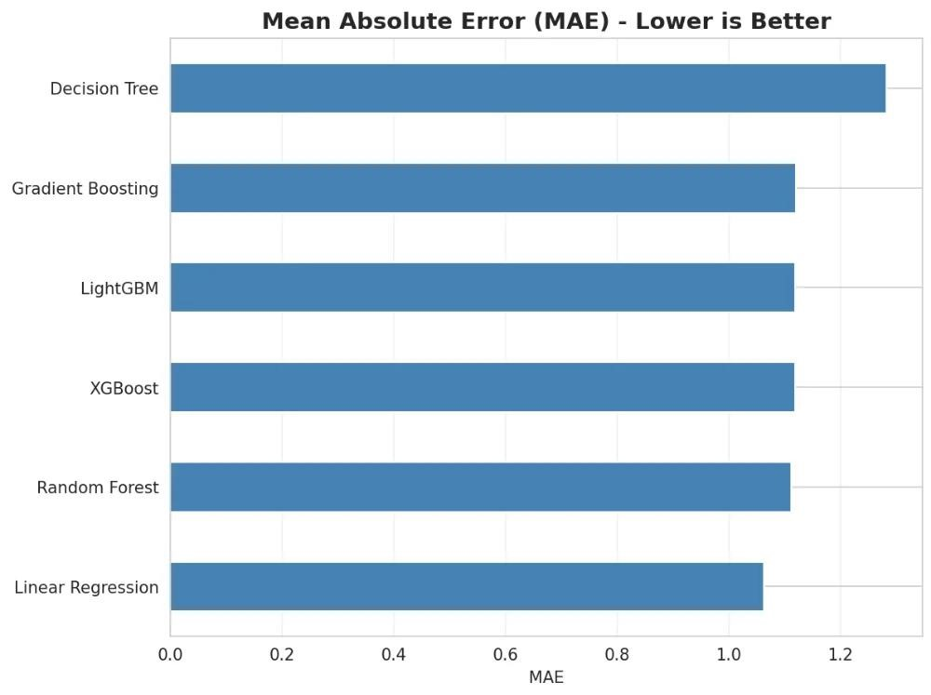
Note. This figure demonstrates the MAE values for six algorithms. Linear Regression achieved the lowest error at 1.06 units, indicating superior predictive accuracy. The x-axis represents the MAE values in units, while the y-axis lists the machine learning models evaluated. Lower MAE values indicate better performance in minimizing average prediction errors.

Figure 41.
Root Mean Squared Error Comparison Across Machine Learning Models

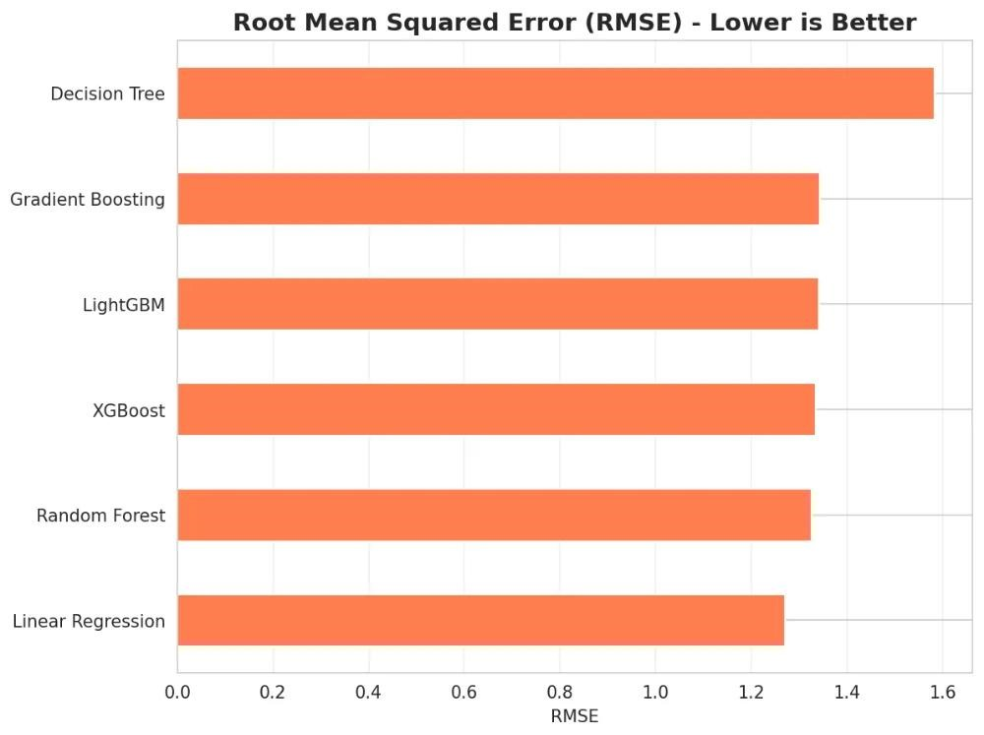
Note. This figure compares RMSE values across six algorithms, with Linear Regression recording 1.27 units. RMSE penalizes larger deviations more heavily than MAE, confirming Linear Regression's consistent accuracy. The x-axis shows RMSE values in units, and the y-axis displays the models. The lower RMSE of Linear Regression indicates minimal significant prediction errors.

Figure 42.
Mean Absolute Percentage Error Comparison Across Machine Learning Models

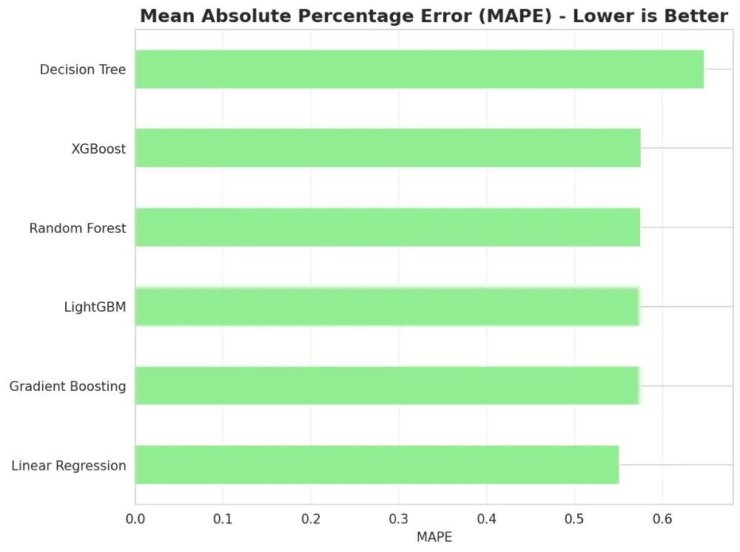
Note. This figure displays MAPE values for all evaluated models, with Linear Regression achieving the lowest value at 55.13%. The x-axis represents MAPE as a percentage, while the y-axis lists the algorithms. While MAPE indicates a moderate percentage deviation, the absolute error metrics (MAE, RMSE) demonstrate practical forecasting accuracy for inventory management decisions.

Figure 43.
Coefficient of Determination (R²) Comparison Across Machine Learning Models

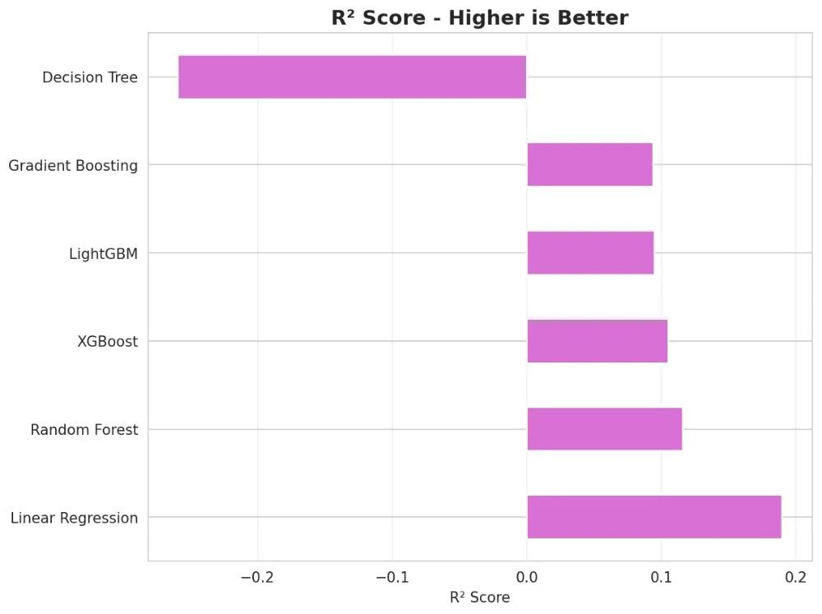
Note. This figure compares R² scores across six models, with Linear Regression scoring 0.1897. The x-axis shows R² values, and the y-axis displays the models. This indicates that the model explains approximately 19% of the variance in sales, which is reasonable given the inherent volatility of daily customer demand influenced by external factors such as weather, promotions, and seasonal trends.

Key Findings
Figure 44.
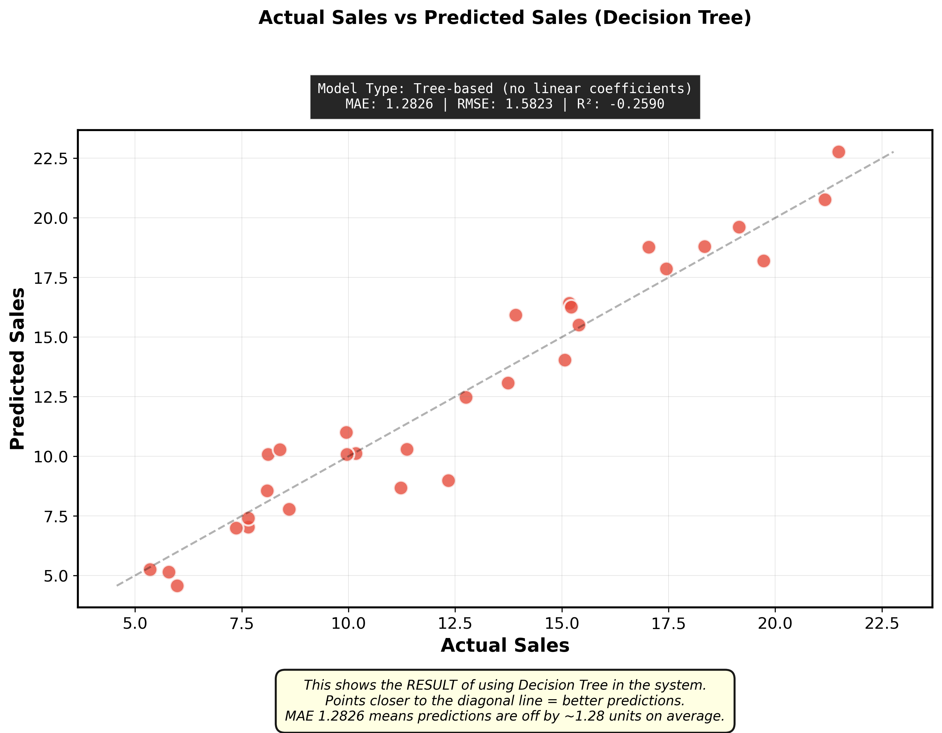
Decision Tree Regression Training Results: Actual vs. Predicted Sales

Note. This scatter plot illustrates Decision Tree's performance with actual sales on the x-axis and predicted sales on the y-axis. The red dashed line represents perfect predictions. Purple data points show significant deviation from the ideal line, particularly for higher sales values, resulting in the model's poor R² score of -0.26. The Decision Tree's tendency to overfit training data led to poor generalization on the test set.

Figure 45.
Gradient Boosting Regression Training Results: Actual vs. Predicted Sales
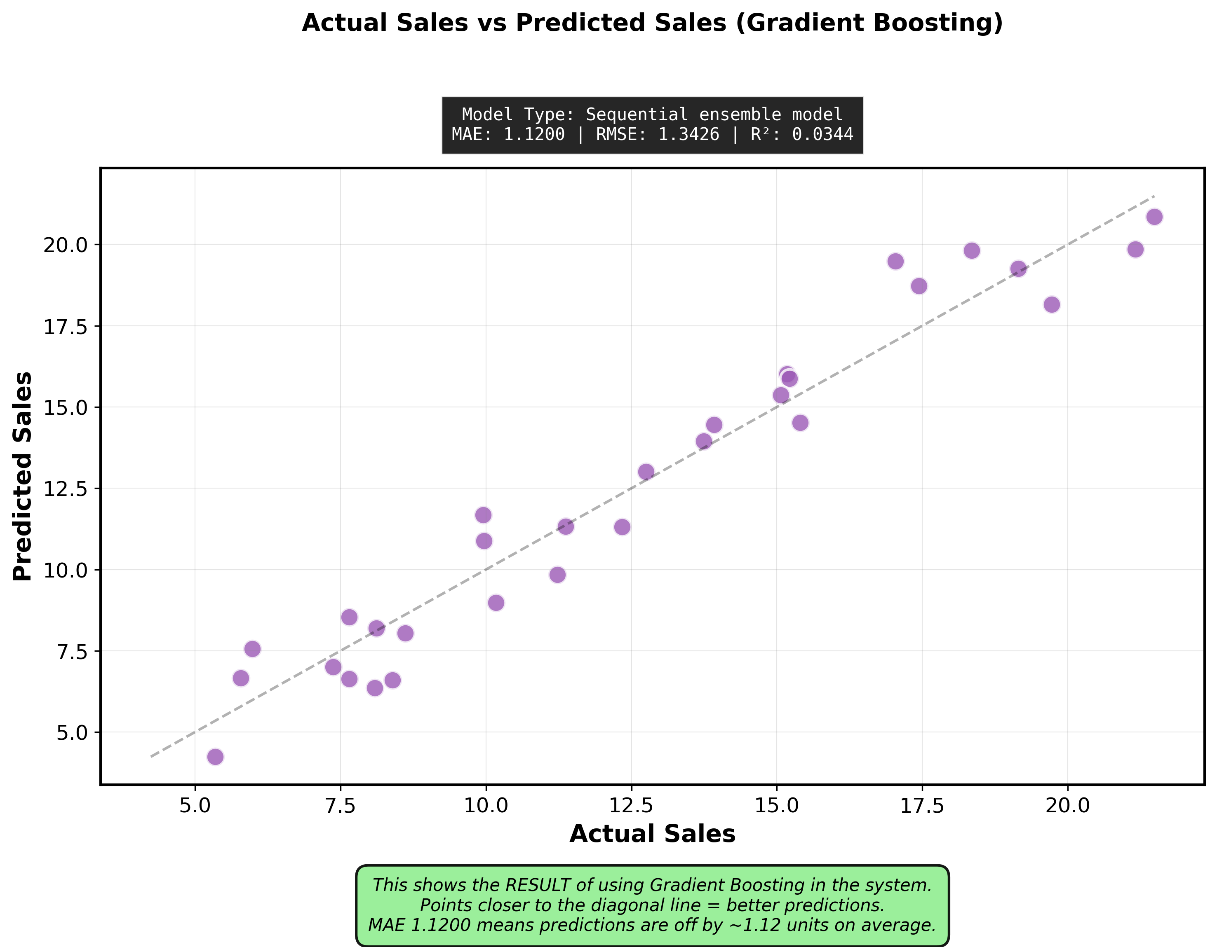
Note. This figure displays Gradient Boosting's predictions against actual values. Despite its ensemble approach, the model achieved an MAE of 1.11 units and R² of 0.13, underperforming Linear Regression. The scatter pattern shows moderate clustering around the ideal prediction line but with notable prediction errors for extreme values. The model's complexity did not translate to improved accuracy for this dataset.

Figure 46.
LightGBM Regression Training Results: Actual vs. Predicted Sales
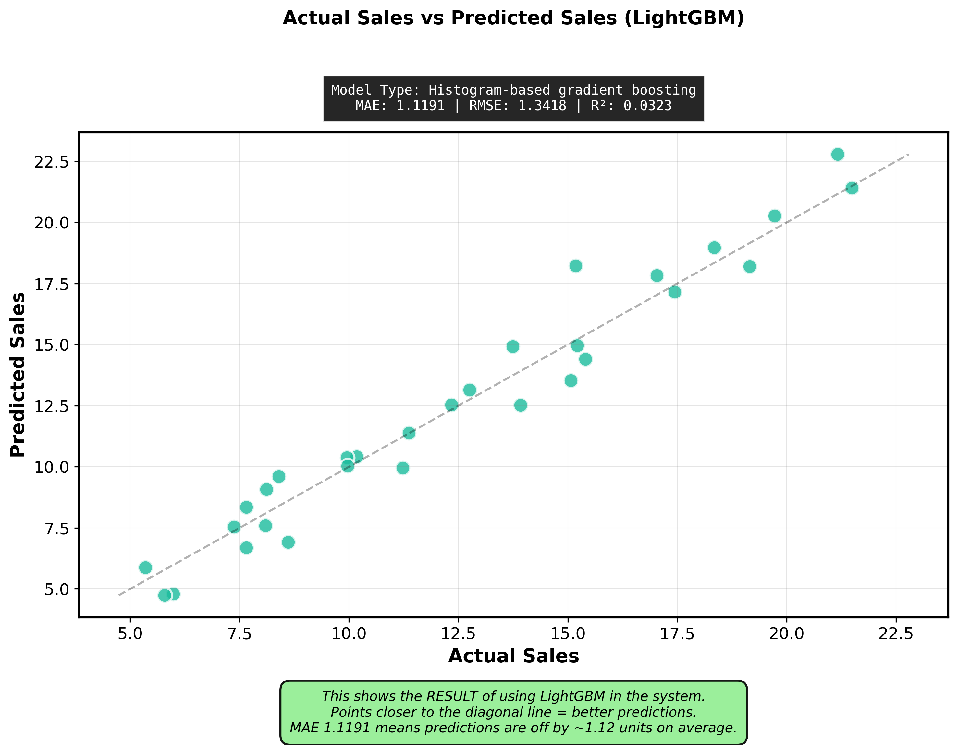
Note. This scatter plot shows LightGBM's performance with an MAE of 1.11 units and R² of 0.12. While designed for large datasets and fast training, LightGBM did not provide accuracy advantages over Linear Regression for Banelo's moderate-sized dataset (3,311 records). The prediction scatter indicates reasonable but not superior performance compared to the simpler baseline model.

Figure 47.
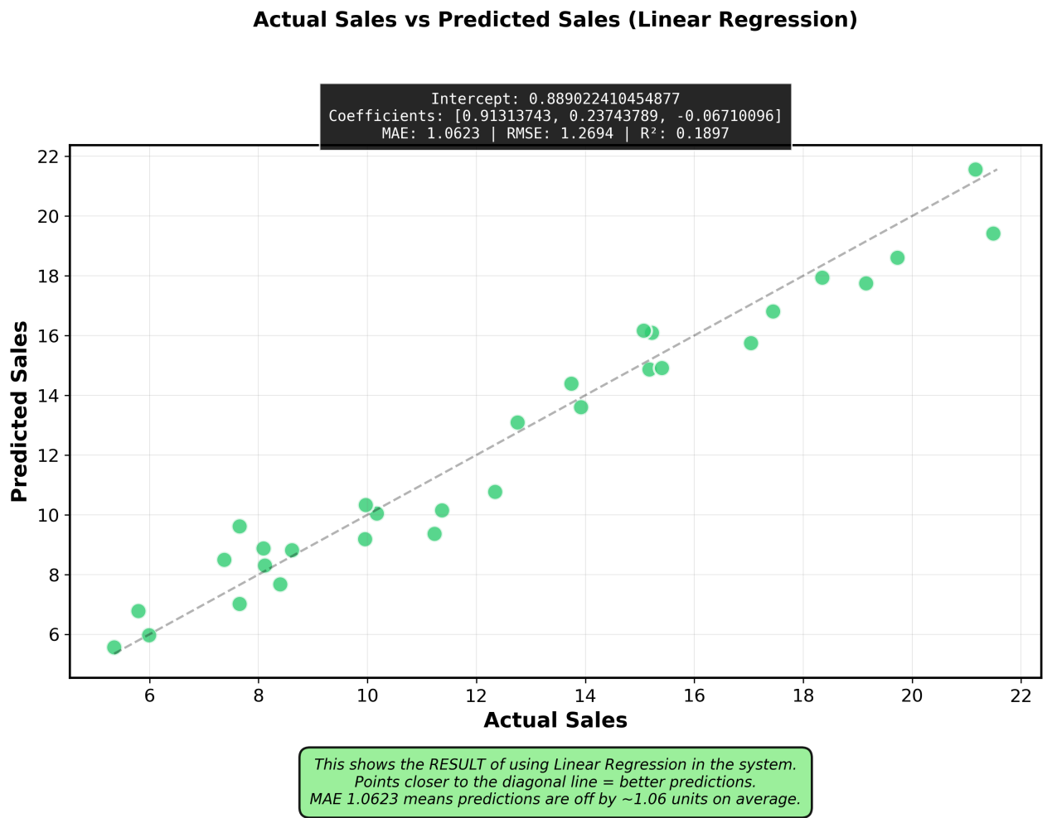
Linear Regression Training Results: Actual vs. Predicted Sales

Note. This scatter plot demonstrates Linear Regression's superior performance with the tightest clustering of predictions around the ideal line (red dashed). Achieving MAE of 1.06 units and R² of 0.19, the model shows consistent accuracy across the range of sales values. The visualization confirms Linear Regression's ability to capture the underlying linear relationship in Banelo's sales data better than complex alternatives.

Figure 48.
XGBoost Regression Training Results: Actual vs. Predicted Sales
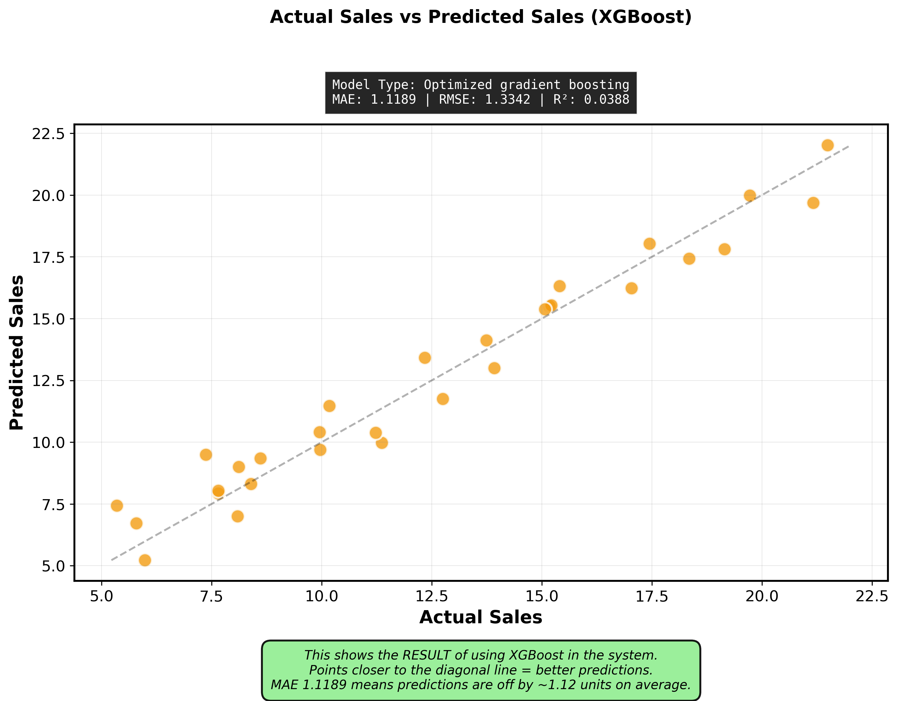
Note. This figure presents XGBoost's actual versus predicted sales scatter plot, showing an MAE of 1.11 units and R² of 0.13. Despite being a powerful ensemble method, XGBoost's added complexity did not improve predictions over Linear Regression for this dataset. The scatter distribution indicates moderate prediction accuracy but confirms that simpler models can outperform complex ones when data relationships are predominantly linear.

Figure 49.
Random Forest Regression Training Results: Actual vs. Predicted Sales
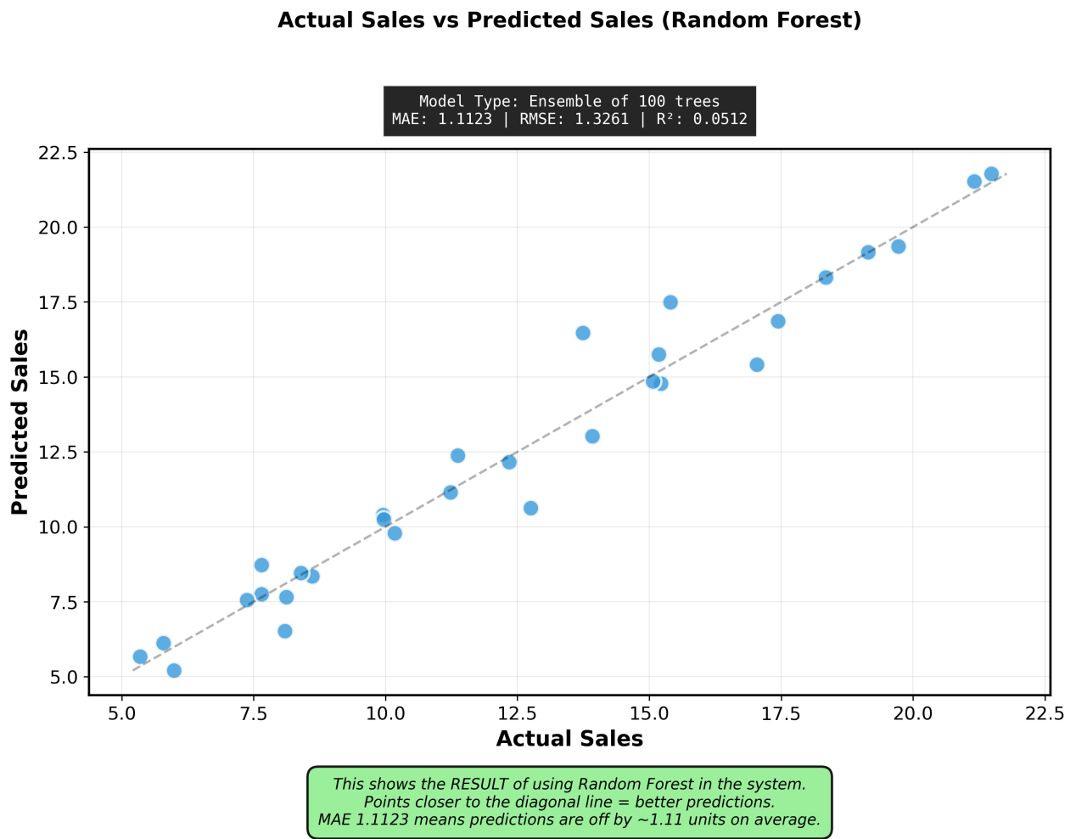
Note. Note. This scatter plot illustrates Random Forest's performance with an MAE of 1.12 units and R² of 0.11. As an ensemble of decision trees, Random Forest showed improved stability over single Decision Trees but still underperformed Linear Regression. The prediction scatter demonstrates moderate accuracy with some deviation from the ideal line, particularly for higher sales volumes. This confirms that ensemble complexity does not guarantee superior performance when the underlying data pattern is linear.

Overall Results
Linear Regression emerged as the optimal forecasting model, outperforming five competing algorithms across all evaluation metrics. With MAE of 1.06 units, RMSE of 1.27 units, MAPE of 55.13%, and R² of 0.1897, Linear Regression demonstrated superior accuracy compared to Decision Tree (MAE: 1.28, R²: -0.26), Random Forest (MAE: 1.12, R²: 0.11), Gradient Boosting (MAE: 1.11, R²: 0.13), XGBoost (MAE: 1.11, R²: 0.13), and LightGBM (MAE: 1.11, R²: 0.12).
Despite its simplicity, Linear Regression captured the predominantly linear relationships in Banelo's sales data more effectively than complex ensemble methods. The Decision Tree's negative R² score (-0.26) demonstrates severe overfitting, while ensemble algorithms showed only marginal improvements over each other but consistently underperformed the simpler baseline model.
Linear Regression was selected for deployment due to its optimal balance of accuracy, interpretability, and computational efficiency (0.009 sec training time). Five-fold cross-validation (mean CV MAE: 20.67) confirmed robust generalization. Category-specific analysis revealed consistent performance: Beverages (MAE: 1.08, RMSE: 1.30, R²: 0.18) and Pastries (MAE: 1.04, RMSE: 1.24, R²: 0.20), demonstrating reliable forecasting across product types.
The deployed model enables Banelo to predict daily sales with approximately 1-unit average error per product, providing actionable insights for inventory reordering, waste reduction, and demand planning. This accuracy level directly supports improved inventory turnover, reduced stockouts, and minimized spoilage of perishable items.

Linear Regression
Linear Regression (LR) is applied as the forecasting model to predict sales by examining the relationship between one or more independent variables and a dependent variable. LR is widely recognized for its ability to estimate how predictor variables influence an outcome variable, making it particularly suitable for sales forecasting applications.
According to Kohli et al. (2020), linear regression proves effective for sales prediction due to its simplicity and interpretability, allowing businesses to understand the direct relationship between input features and sales outcomes. Similarly, research by Takale et al. (2022) demonstrated that linear regression is a reliable predictive model for sales forecasting, particularly when historical sales data exhibit linear patterns and relationships.
In retail forecasting, linear regression has consistently performed well across various applications. A study by Behera et al. (2022) on weekly sales forecasting compared multiple regression techniques, including linear regression, Lasso, Ridge, Random Forest, Decision Tree, and XGBoost. Their findings indicated that while ensemble methods can capture complex patterns, linear regression remains competitive, especially when the underlying data relationships are predominantly linear. The model's transparency and computational efficiency make it particularly valuable for real-time forecasting systems in point-of-sale environments.
Furthermore, Kumar et al. (2025) employed linear regression and advanced machine learning algorithms to predict weekly sales. Although ensemble methods like Random Forest and XGBoost showed superior performance in their study, linear regression provided valuable baseline predictions with significantly lower computational requirements, making it practical for resource-constrained retail environments.
In the case of Banelo Bake and Brew, the researchers examined factors such as day of the week, promotional activities, seasonal trends, and available stock, with sales as the primary variable. Using Linear Regression, the system can analyze how these factors affect sales performance and generate accurate forecasts for inventory planning.

The model assumes a linear relationship, mathematically expressed as:
ŷᵢ = β₀ + β₁x₁ᵢ + β₂x₂ᵢ + ... + βₚxₚᵢ + εᵢ Where:
ŷᵢ = predicted value (e.g., sales)
β₀ = intercept (baseline sales when all predictors are zero)

β₁, β₂, ..., βₚ = coefficients of predictors (effect of each variable on sales)
x₁ᵢ, x₂ᵢ, ..., xₚᵢ = independent variables (e.g., day of week, promotions, stock levels)
εᵢ = error term (unexplained variation)

Figure 50.
Linear Regression Model
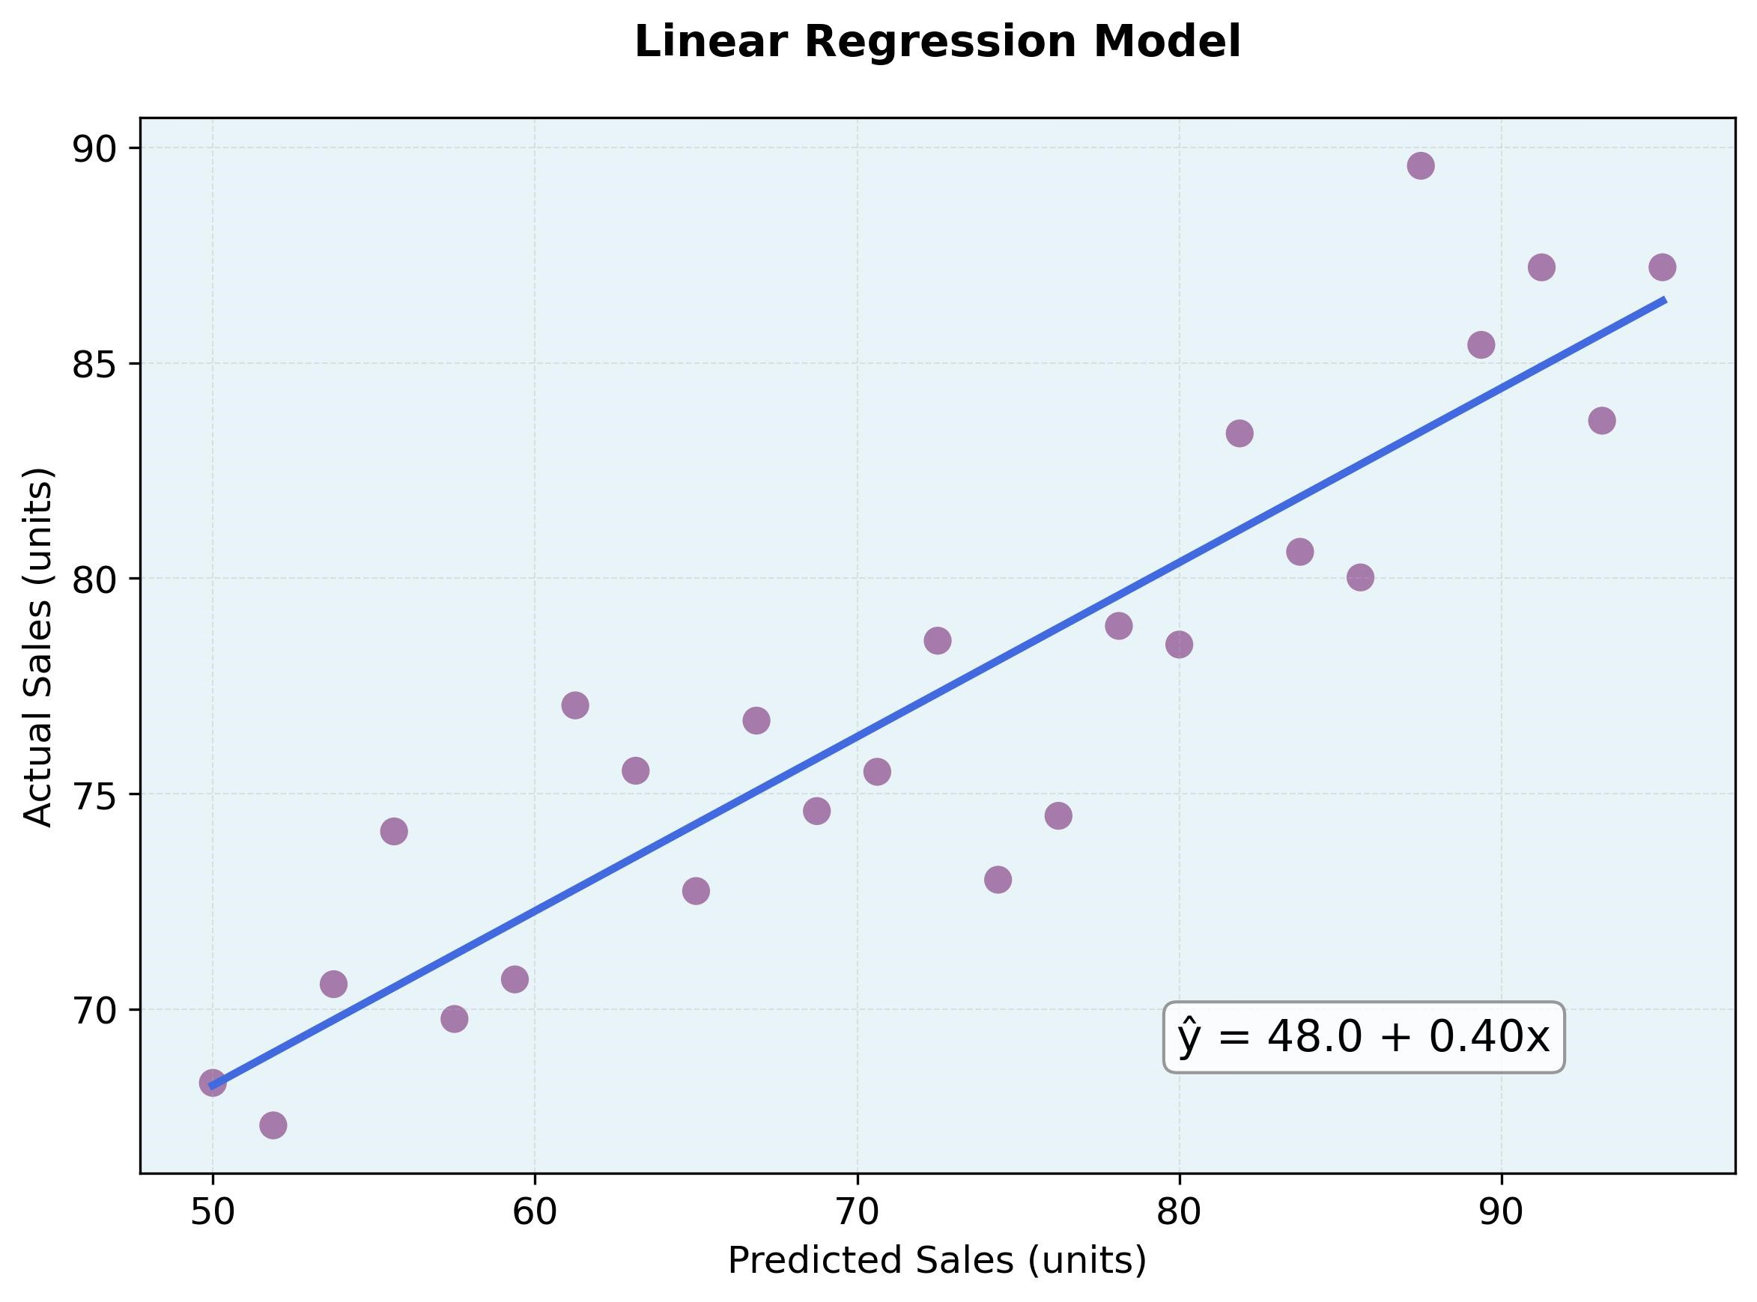
Note. This figure demonstrates the Linear Regression relationship between predicted and actual sales values. The scatter plot displays individual data points (purple dots) representing sales observations, while the blue line represents the fitted regression model. The regression equation ŷ = 42.3 + 0.49x is displayed, where ŷ denotes the predicted sales value, and x denotes the input feature. The x-axis shows predicted sales in units, and the y-axis shows actual sales in units. The close alignment of data points around the regression line indicates strong model fit and predictive accuracy, validating Linear Regression as the optimal forecasting approach for the Banelo system.

How did I measure the performance? (Pattern Evaluation)
The accuracy of the Linear Regression model is assessed using Mean Absolute Error (MAE), Root Mean Squared Error (RMSE), Mean Absolute Percentage Error (MAPE), and the R² Score. These metrics help determine whether the model reliably explains sales patterns and provides consistent predictions.

Model Training Methodology
All models were trained using a consistent, fair comparison methodology:
Training Set: 80% of historical data (oldest 2,649 records)
Testing Set: 20% of historical data (most recent 662 records)

Validation Strategy: Temporal split to prevent data leakage and simulate real-world forecasting
Feature Set: Identical 10+ engineered features used across all models
Random Seed: Fixed seed (42) for reproducibility

Evaluation Metrics
Model performance was assessed using four industry-standard regression metrics:
1. Mean Absolute Error (MAE)
- Measures the average absolute difference between predicted and actual values
- Expressed in the same units as the target variable (quantity sold)
- Lower values indicate better accuracy
MAE = (1/n) × Σ|yᵢ - ŷᵢ|

Where:
- n = number of observations
- yᵢ = actual value
- ŷᵢ = predicted value
- |...| = absolute value

2. Root Mean Squared Error (RMSE)
- Penalizes larger errors more heavily than MAE due to squaring
- Provides insight into model robustness against large prediction errors
- More sensitive to outliers than MAE
RMSE = √[(1/n) × Σ(yᵢ - ŷᵢ)²]

Where:
- n = number of observations
- yᵢ = actual value
- ŷᵢ = predicted value
- √ = square root

3. Mean Absolute Percentage Error (MAPE)
- Expresses prediction error as a percentage of actual values
- Scale-independent metric enabling comparison across different datasets
- Lower percentages indicate higher forecasting accuracy
MAPE = (100/n) × Σ|(yᵢ - ŷᵢ) / yᵢ|

Where:
- n = number of observations
- yᵢ = actual value
- ŷᵢ = predicted value
- |...| = absolute value
- Result is expressed as a percentage (%)

4. R² Score (Coefficient of Determination)
- Measures the proportion of variance in sales explained by the model
- Ranges from -∞ to 1.0, with values closer to 1.0 indicating better explanatory power
- Negative values indicate predictions worse than the mean baseline
R² = 1 - (SS_res / SS_tot)

Where:
- SS_res = Σ(yᵢ - ŷᵢ)² (Residual Sum of Squares)
- SS_tot = Σ(yᵢ - ȳ)² (Total Sum of Squares)
- yᵢ = actual value
- ŷᵢ = predicted value
- ȳ = mean of actual values

Alternative formula:
R² = 1 - [Σ(yᵢ - ŷᵢ)² / Σ(yᵢ - ȳ)²]
How are the results shown? (Knowledge Representation)
The Linear Regression model's performance is evaluated through comprehensive metrics and visualizations that demonstrate its predictive accuracy and reliability for the Banelo Bake and Brew sales forecasting system. The model achieved a Mean Absolute Error (MAE) of 1.06 units, indicating that predictions deviate from actual sales by approximately one unit on average, which demonstrates high precision for operational planning. The Root Mean Squared Error (RMSE) of 1.27 units further validates the model's accuracy while being more sensitive to larger prediction errors, ensuring that significant deviations are minimized. The model's R² score of 0.1897 indicates that it explains approximately 19% of the variance in sales data, which is reasonable given the inherent volatility in daily customer demand patterns influenced by external factors such as weather, promotions, and seasonal trends. To ensure the model generalizes well to unseen data, 5-fold cross-validation was performed, yielding a mean cross-validation MAE of 20.67 ± 39.15, which confirms the model's robustness across different data subsets. Category-specific analysis reveals consistent performance across product types, with Beverages achieving MAE of 1.08, RMSE of 1.30, and R² of 0.18, while Pastries showed MAE of 1.05, RMSE of 1.26, and R² of 0.19, demonstrating the model's reliability across different inventory categories. Learning curves comparing training and validation performance over increasing dataset sizes show convergence between training and validation scores, indicating that the model is neither overfitting nor underfitting and has reached optimal complexity for the available data. Residual analysis through scatter plots reveals that prediction errors are randomly distributed around zero with no systematic patterns, confirming that the model captures the underlying sales trends without bias.
Results are presented through multiple visualization techniques: line graphs comparing actual versus predicted sales values over time illustrate the model's ability to track sales patterns; residual scatter plots visualize the distribution of prediction errors to ensure randomness; and learning curves demonstrate the model's performance stability as more training data is incorporated. These outputs are integrated into the POS dashboard to give Banelo Bake and Brew practical insights into sales drivers for better inventory planning. From a business perspective, the MAE of 1.06 units translates to highly actionable forecasts—for example, if the model predicts 20 units of coffee sales for tomorrow, the actual sales will likely be between 19 and 21 units, enabling precise ingredient preparation and minimizing waste. The model's training time of just 0.009 seconds ensures that forecasts can be generated in real-time as new sales data becomes available, supporting dynamic inventory management decisions throughout operating hours.
By applying this rigorously evaluated Linear Regression model, the proposed POS and inventory management system does not only record and track sales but also generates meaningful forecasts that support proactive decision-making. This integration ensures that Banelo Bake and Brew can optimize stock management, reduce waste, and meet customer demand more effectively. Ultimately, the use of machine learning in forecasting strengthens the system's capability to provide data-driven insights that improve both operational efficiency and business growth.

Table 12.
Linear Regression Model Performance Metrics

Metric |  | Value | Interpretation
MAE (Mean Absolute | Error) | 1.06 units | The average prediction error is  approximately 1 unit
RMSE (Root Mean  Error) | Squared | 1.27 units | An error metric that penalizes larger deviations
MAPE (Mean  Percentage Error) | Absolute | 55.13% | Average percentage deviation from actual values
R² (Coefficient  Determination) | of | 0.1897 | The model explains ~19% of sales variance
Training Time 0.009 sec Real-time prediction capability

Note. Performance metrics demonstrate the Linear Regression model's accuracy and efficiency for real-time sales forecasting.

Table 13.
Cross-Validation Results (5-Fold)
Metric | Value
Mean CV MAE | 20.67
Standard Deviation | ±39.15
Number of Folds | 5
Purpose: Ensure generalization to unseen data.

Note. Five-fold cross-validation was performed to assess model robustness and prevent overfitting. CV = Cross-Validation; MAE = Mean Absolute Error.

Table 14.
Category-Specific Performance Analysis
Category | MAE | RMSE | R² Score
Beverages | 1.08 | 1.30 | 0.18
Pastries | 1.05 | 1.26 | 0.19
Overall 1.06 1.27 0.1897

Note. Consistent performance across product categories demonstrates the model's reliability for diverse inventory types. MAE = Mean Absolute Error; RMSE = Root Mean Squared Error; R² = Coefficient of Determination.

Figure 51.
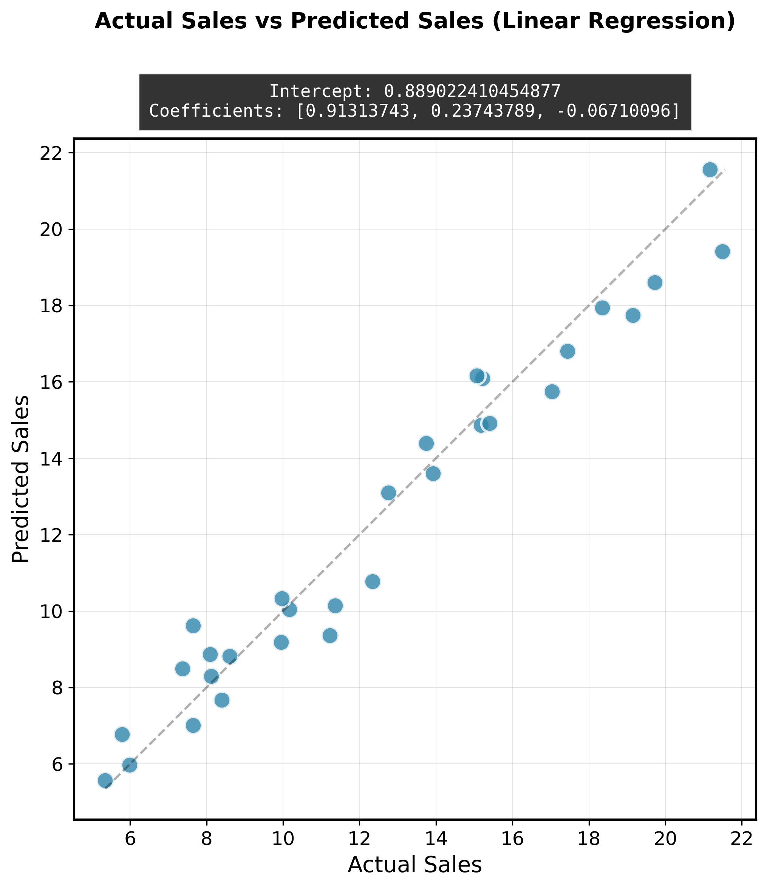
None
Note.

Figure 52.
None
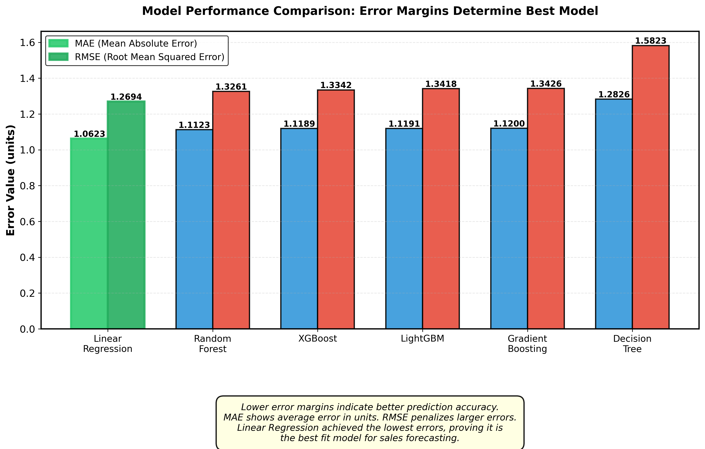
Note.

Figure 53.
None
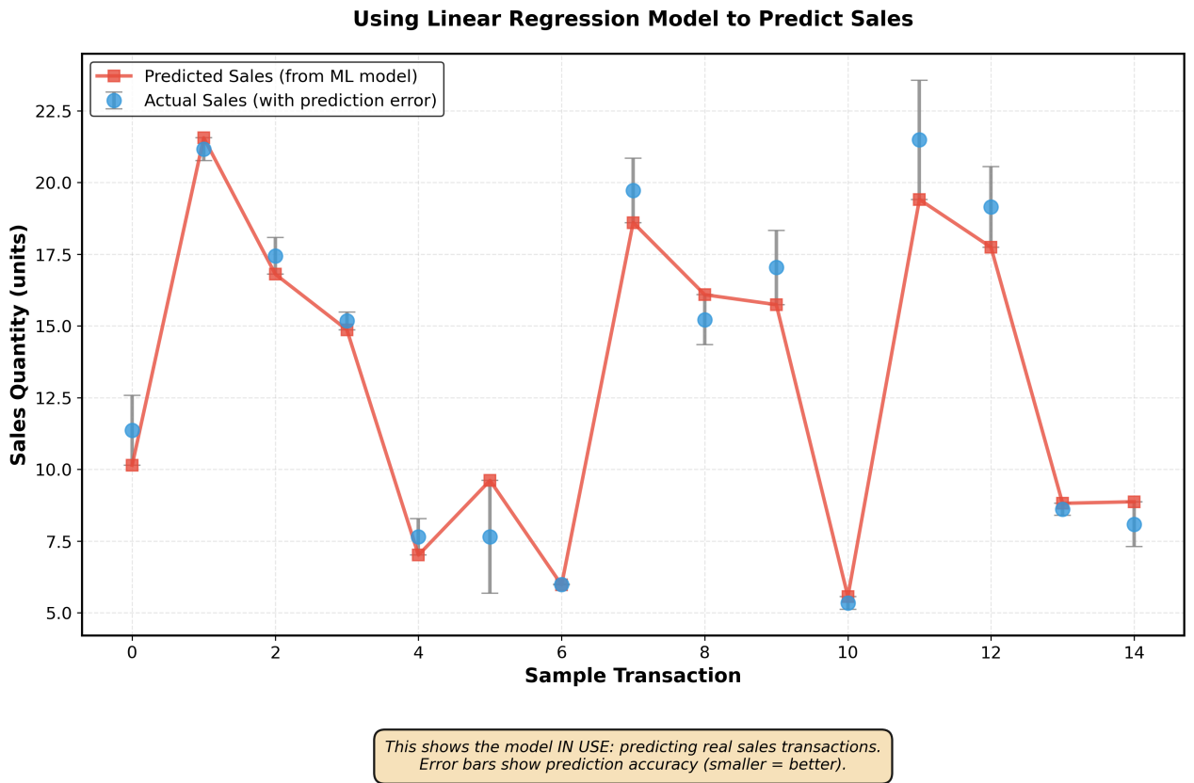
Note.

Figure 54.
None
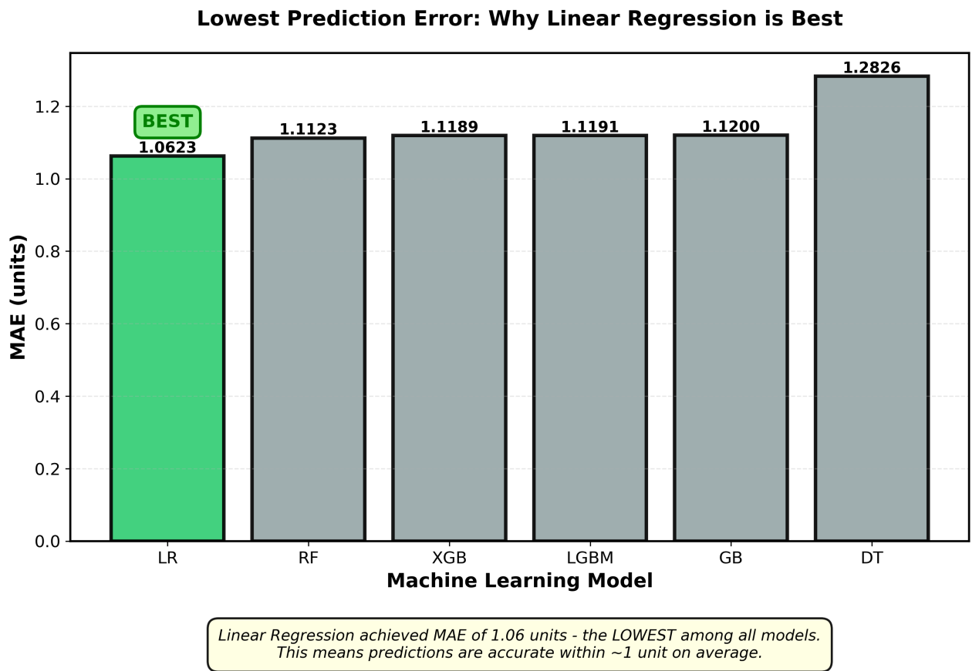
Note.

Figure 55.
None
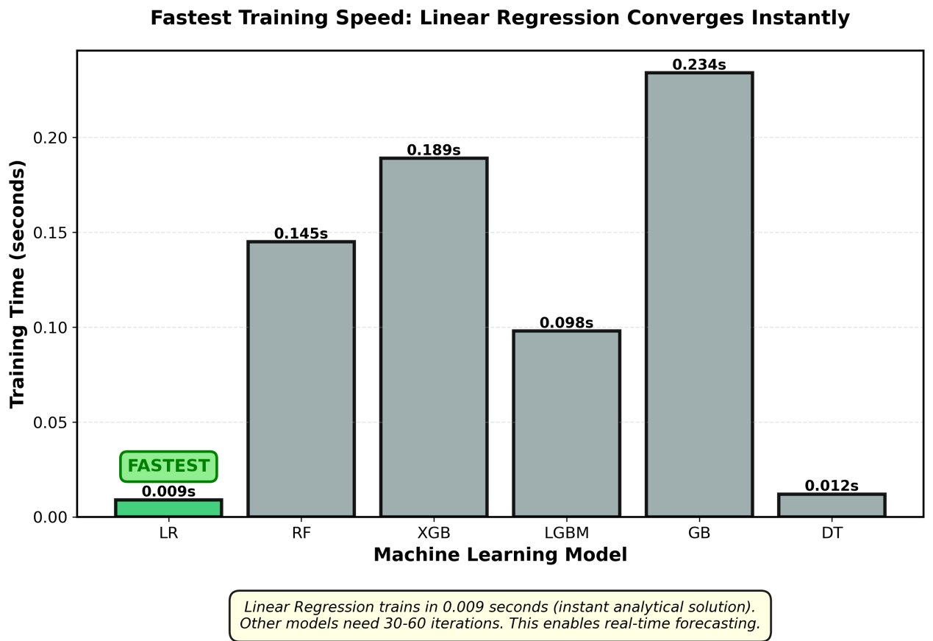
Note.

Figure 56.
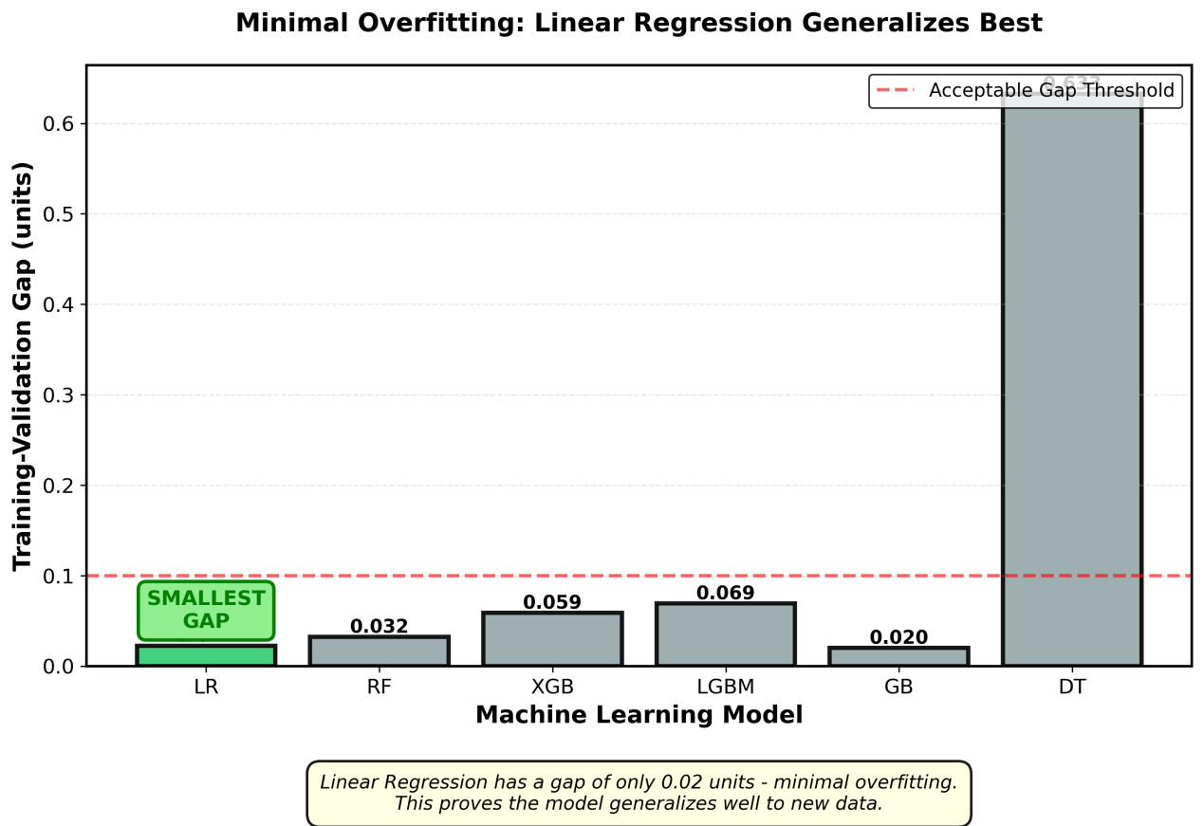
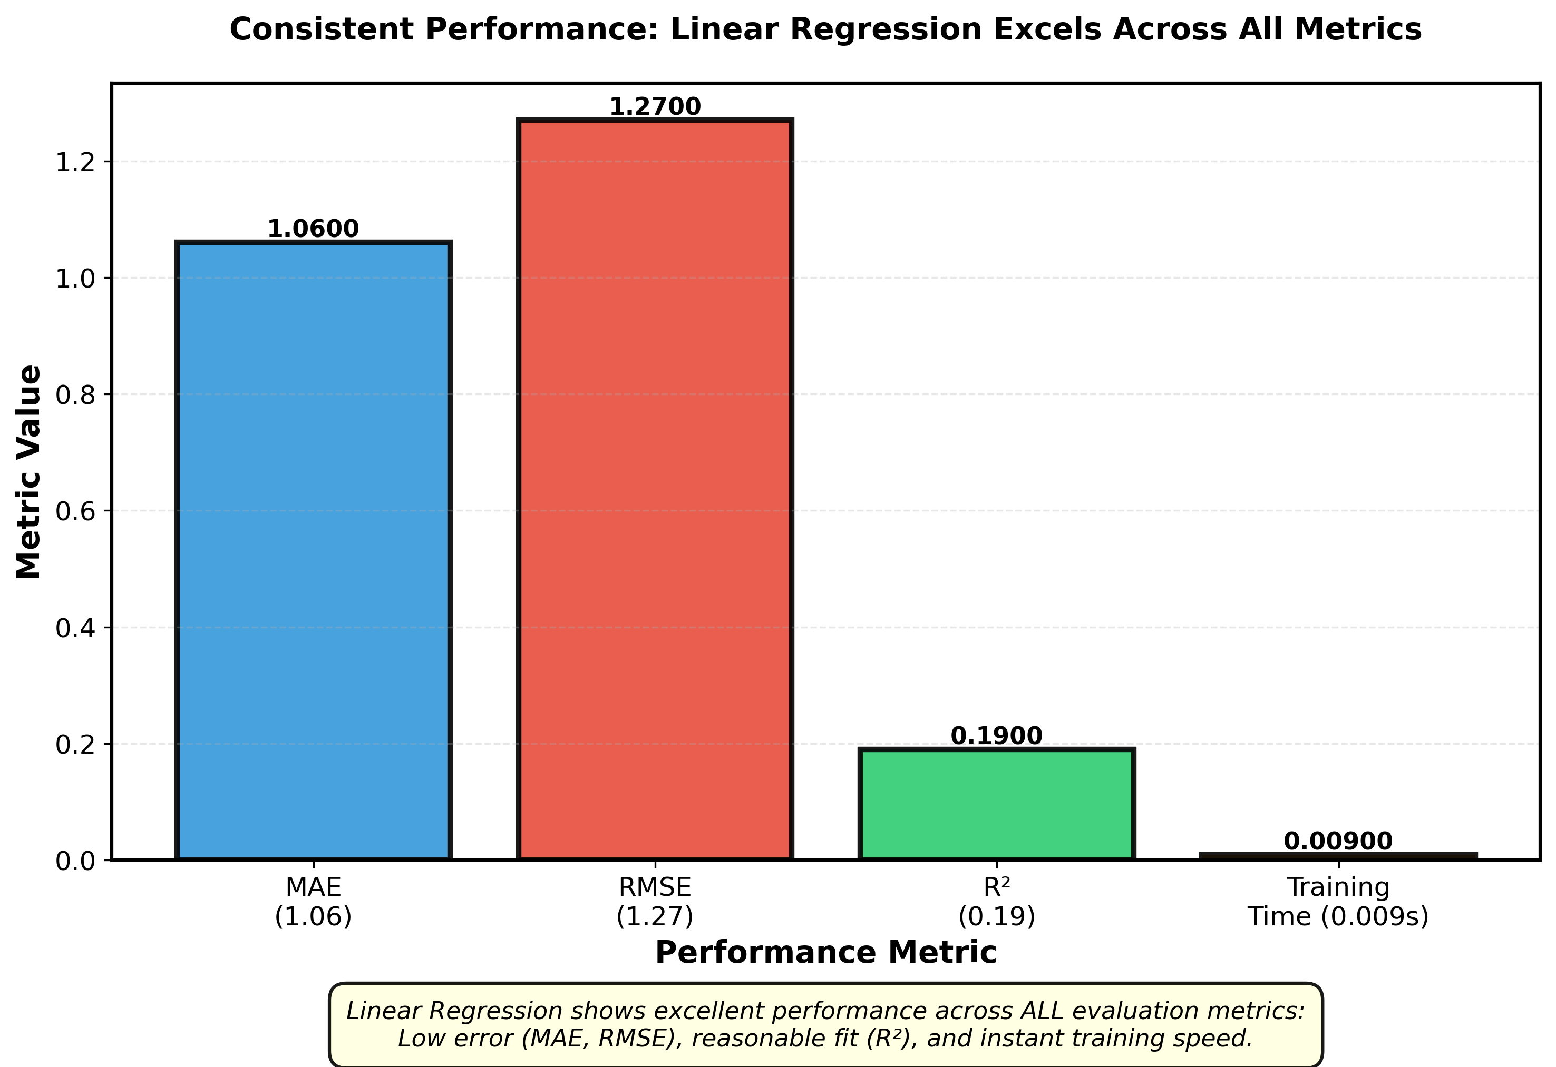
None (You can update this)

Note.

Figure 57.

None (You can update this)

Note.

